Rahul Jayaraman

Dr. Eric R. Nelson

ATCS: Numerical Methods

30 October 2014

Projectile Motion: Can We Drag Ourselves Out Of Erroneous Models?

**Introduction**

Numerical methods can prove very useful to simulate many physical phenomena that may not have a closed-form solution, such as projectile motion with drag and the N-body problem. In this paper, we specifically focus on the applications of numerical methods to analyze projectile motion with drag forces in both the x- and y-dimensions.

We first implemented an algorithm for Euler’s method, an SN-order method to solve first-order differential equations. Our implementation involves the use of a method that uses a while loop and takes in four parameters: a starting x-value, an ending x-value, a starting y-value, and an array of coefficients for the differential equation; this equation can take various forms, including trigonometric, polynomial, and exponential.

Through the use of Euler’s method applied to an arbitrary acceleration function (that may or may not involve appropriate drag forces) given a starting velocity, we obtained a set of velocity data. At the time that the projectile hit the ground (obtained from position data and back-calculated), we compared the x-velocity to the starting x-velocity, as both must be the same. We also used similar logic for the y-velocity, albeit with reversed signs. Comparing the observed values to a non-drag, closed-form model forms the basis of this paper.

Of course, our analysis of the forces must have some constants previously defined. Our projectile in this project was a 5.5 kg cannonball, with a radius of 10.5 cm (diameter 21 cm) and drag coefficient of 0.45; the cannonball was fired at a 45o angle from the horizontal. Our step size for the Euler’s method function was 0.1, and the value of *g* (the gravitational field strength on Earth) that we used in our force analysis was 9.81 (m/s2). In our methods, we must also have two separate while loops – as the acceleration as the cannonball shoots up into the air is not the same as the acceleration as it comes back down, due to the vector nature of this quantity.

**We define divergence from our model as differing more than 5%. For instance, if the value we obtain from our adiabatic analysis is not within 5% of the value we obtain from an analysis without drag forces, then we will call that a “divergent value.”**

**Baseline: No Air Resistance**

*Assumption:* In this model, the projectile faces no air resistance; the only force that it is subject to is gravity.

*Results:* There *is* a closed-form solution for this, and we will use this to verify our numerical analysis results. We expect that the velocity once it hits the ground should be the same as the start velocity (variable *v*). The x-velocity, without drag (or any forces), is obviously the same. However, when we apply Euler’s method with the appropriate initial conditions, we see that as the starting velocity increases, the accuracy of our approximation decreases. By the time we hit |*v*| = 100 m/s, we see that our approximation is 1% off from the actual value predicted by the model. ***This, however, is not a result of drag forces at play. It is merely a result of our simulation and the lack of machine precision when doing a multitude of “piggy-backing” calculations, i.e. those that rely on previous approximations***.

*Analysis and Divergence:* This model, of course, cannot diverge – it is our baseline!

**Constant Air Density**

*Assumptions:* This model assumes a constant air density, or ρ, of 1.225 kg/m3 AMSL at 15o C (Wikipedia).

*Results and Analysis:* Plugging this value into our algorithm, we observe a significant departure from the predicted velocity. The model starts to diverge when the muzzle velocity is 22 m/s, or about 49.2 miles per hour (Fig 1) – about the speed of a car on an expressway. More specifically, the impact velocity without drag is 15.54 m/s, while the impact velocity with constant drag is 14.66 m/s – a deviation of 5.66%, which is above our limit of 5% – indicating the start of divergence from our model.

Fig 1

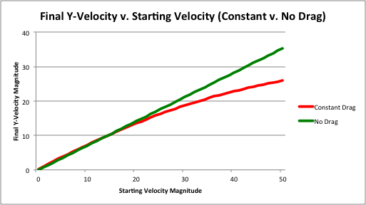This is as expected; we know that the model for drag is a power-law dependent on velocity. As the velocity increases by a factor of 2, for instance, the drag force increases by a factor of 4 (FD v2), thus slowing the object down. As a direct result, we observe an increased acceleration upon impact as starting velocity increases.

**Adiabatic Air Density**

*Assumptions:* For this model, we assume that the temperature was 15o C, or 288 K, at all altitudes attained by the cannonball. We also assume an initial air density ρ of 1.225 kg/m3 AMSL as well as an adiabatic density model for the atmosphere (ρ = ρo, in which there is negligible heat transfer with air movement.

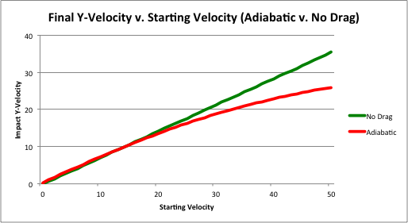 *Results and Analysis*: We can see that there is not a significant departure from the constant drag model for the altitude that we normally fire cannons at; indeed, at 50 m/s (112 mph), the adiabatic and constant-drag models only differ by .006% -- well within our divergence limit. In fact, using an adiabatic model results in a slightly higher impact velocity due to the slightly lessened drag at “higher” altitudes, such as the peak of the cannonball’s flight. As we increase our altitude *significantly* (by thousands of meters), density becomes negligible, and we observe results that are closer to the no-drag model. Shifting our focus back to the ground, we can see in Fig 2 that the adiabatic model starts to diverge from the no-drag model at 22 m/s (just like the constant-drag model):

Fig 2

We also observe the obvious lack of divergence between the adiabatic and constant-drag models in Fig 3 (Note: We use a 3-D graph here so that we can see both the models; using a 2D graph, one model covers the other):

Fig 3

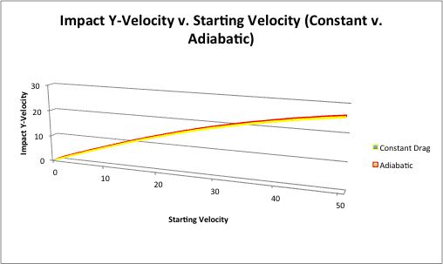 **Isothermal Air Density**

We now arrive at the last of our models, the isothermal density model (ρ = ρo).

*Assumptions:* In this model, we assume that all parts of the atmosphere traveled by the cannonball are at the same temperature, 15oC (288 K). We also assume an initial air density ρ of 1.225 kg/m3 AMSL.

*Results and Analysis*: Here goes shit about adiabatic v isothermal, FIX A v. N graph

lol

swag

Here goes more shit but about isothermal v no drag, become more precise in the other stuff (22.7 ?? or s/t)